<https://www.youtube.com/watch?v=jvkhKRHS2TY&ab_channel=knowcity>

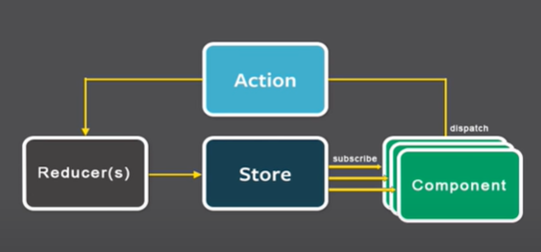



<https://www.youtube.com/watch?v=wzWZDh0dUYE&ab_channel=knowcity>

